Submitted by : Anil chand

LCID:LC00017002602



Texas



College



of



Management



and



IT



Internet Fundamental and



Application



Explore,



Learn



and



Excel



Mini

-

Project



HTML, CSS and Bootstrap



Program: BIT

Semester: second

Submitted to : Texas college of management

Table of content

1. Introduction
2. Project Objective
3. Technologies Used
4. Main Topics Covered
   * 4.1. HTML Structure
   * 4.2. CSS Styling
   * 4.3. Bootstrap Integration

•

1. Code Implementation
   * HTML home page code
   * About page code
   * Skill page code
   * Contact page code
   * CSS Code
2. Errors Faced and Solutions
3. Results Achieved
4. Conclusion
5. References

# INTRODUCTION

This [project](C:\\Users\\ASUS\\OneDrive\\Desktop\\project\\index.html) involves designing a professional web designer portfolio using HTML, CSS, and Bootstrap. The goal is to create a responsive, visually appealing, and user-friendly website that showcases the skills and projects of a web designer.

1. Project Objective

The objective of this project is to build a portfolio website that demonstrates the web designer's expertise in HTML, CSS, and Bootstrap. The portfolio will feature various sections, including an introduction, skills, portfolio pieces, and contact information.

1. Technologies Used
   * + HTML5: To structure the content of the portfolio.
     + CSS3: For styling and layout of the website.
     + Bootstrap 5: For responsive design and pre-built components.

1. Main Topics Covered
   1. HTML Structure

The HTML file was organized into sections, home, about me, skills,, contact sections. Semantic tags like <header>, <section>, and <footer> were used to enhance the structure and accessibility.

* 1. CSS Styling

Custom CSS was written to style the website. Colors, fonts, and layouts were defined to create a cohesive design that reflects the designer's personal brand.

* 1. Bootstrap Integration

Bootstrap was integrated to ensure the website is responsive across various devices. Pre-built Bootstrap components, such as the navigation bar, grid system, and buttons, were used to enhance functionality and design.

Code Implementation

1.Index.html

<!DOCTYPE html>

<html lang="en">

<head>

<meta charset="UTF-8">

<meta name="viewport" content="width=device-width, initial-scale=1.0">

<title>Anil Chand - Web Designer Portfolio</title>

<link

href="https://maxcdn.bootstrapcdn.com/bootstrap/4.5.2/css/bootstrap.min.css " rel="stylesheet">

<link rel="stylesheet" href="styles.css">

</head>

<body>

<nav class="navbar navbar-expand-lg navbar-dark bg-dark">

<a class="navbar-brand" href="index.html">Anil Chand</a>

<button class="navbar-toggler" type="button" data-toggle="collapse" data-target="#navbarNav" aria-controls="navbarNav" ariaexpanded="false" aria-label="Toggle navigation">

<span class="navbar-toggler-icon"></span>

</button>

<div class="collapse navbar-collapse" id="navbarNav">

<ul class="navbar-nav">

<li class="nav-item">

<a class="nav-link" href="index.html">Home</a>

</li>

<li class="nav-item">

<a class="nav-link" href="about.html">About</a>

</li>

<li class="nav-item">

<a class="nav-link" href="skills.html">Skills</a>

</li>

<li class="nav-item">

<a class="nav-link" href="contact.html">Contact</a>

</li>

</ul>

</div>

</nav>

<header class="hero bg-primary text-black text-center">

<div class="container">

<img src="profile.jpg.jpg" class=" profile-img" alt="Anil Chand">

<h1 class="display-4">Anil Chand</h1>

<p class="lead">Professional Web Designer</p>

</div>

</header>

<section class="container text-center my-5">

<h2>Welcome to My Portfolio</h2>

<p>With expertise in HTML, CSS, JavaScript, React, and Python, I create stunning websites tailored to your needs. Explore my work and get in touch.</p>

</section>

<footer class="bg-dark text-white text-center py-3">

<p>&copy; 2024 Anil Chand. All rights reserved.</p>

</footer>

<script src="https://code.jquery.com/jquery-3.5.1.slim.min.js"></script>

<script

src="https://cdn.jsdelivr.net/npm/@popperjs/core@2.5.4/dist/umd/popper.mi n.js"></script>

<script src="https://stackpath.bootstrapcdn.com/bootstrap/4.5.2/js/bootstrap.min.js" ></script>

</body>

</html>

2.About.html

<!DOCTYPE html>

<html lang="en">

<head>

<meta charset="UTF-8">

<meta name="viewport" content="width=device-width, initial-scale=1.0">

<title>About Anil Chand</title>

<link

href="https://maxcdn.bootstrapcdn.com/bootstrap/4.5.2/css/bootstrap.min.css " rel="stylesheet">

<link rel="stylesheet" href="styles.css">

</head>

<body>

<nav class="navbar navbar-expand-lg navbar-dark bg-dark">

<a class="navbar-brand" href="index.html">Anil Chand</a>

<button class="navbar-toggler" type="button" data-toggle="collapse"

data-target="#navbarNav" aria-controls="navbarNav" ariaexpanded="false" aria-label="Toggle navigation">

<span class="navbar-toggler-icon"></span>

</button>

<div class="collapse navbar-collapse" id="navbarNav">

<ul class="navbar-nav">

<li class="nav-item">

<a class="nav-link" href="index.html">Home</a>

</li>

<li class="nav-item">

<a class="nav-link" href="about.html">About</a>

</li>

<li class="nav-item">

<a class="nav-link" href="skills.html">Skills</a>

</li>

<li class="nav-item">

<a class="nav-link" href="contact.html">Contact</a>

</li>

</ul>

</div>

</nav>

<div class="container my-5">

<h1>About Me</h1>

<p>Hello! I am Anil Chand, a professional web designer with expertise in HTML, CSS, JavaScript, React, and Python. I have worked on various projects including ecommerce websites, photography websites, and tourism agency websites. My goal is to create visually appealing and functional websites that meet client needs.</p>

</div>

<footer class="bg-dark text-white text-center py-3">

<p>&copy; 2024 Anil Chand. All rights reserved.</p>

</footer>

<script src="https://code.jquery.com/jquery-3.5.1.slim.min.js"></script>

<script

src="https://cdn.jsdelivr.net/npm/@popperjs/core@2.5.4/dist/umd/popper.mi n.js"></script>

<script src="https://stackpath.bootstrapcdn.com/bootstrap/4.5.2/js/bootstrap.min.js" ></script>

</body>

</html>

3.Skills.html

<!DOCTYPE html>

<html lang="en">

<head>

<meta charset="UTF-8">

<meta name="viewport" content="width=device-width, initial-scale=1.0">

<title>Skills - Anil Chand</title>

<link

href="https://maxcdn.bootstrapcdn.com/bootstrap/4.5.2/css/bootstrap.min.css " rel="stylesheet">

<link rel="stylesheet" href="styles.css">

</head>

<body>

<nav class="navbar navbar-expand-lg navbar-dark bg-dark">

<a class="navbar-brand" href="index.html">Anil Chand</a>

<button class="navbar-toggler" type="button" data-toggle="collapse" data-target="#navbarNav" aria-controls="navbarNav" ariaexpanded="false" aria-label="Toggle navigation">

<span class="navbar-toggler-icon"></span>

</button>

<div class="collapse navbar-collapse" id="navbarNav">

<ul class="navbar-nav">

<li class="nav-item">

<a class="nav-link" href="index.html">Home</a>

</li>

<li class="nav-item">

<a class="nav-link" href="about.html">About</a>

</li>

<li class="nav-item">

<a class="nav-link" href="skills.html">Skills</a>

</li>

<li class="nav-item">

<a class="nav-link" href="contact.html">Contact</a>

</li>

</ul>

</div>

</nav>

<div class="container my-5">

<h1>My Skills</h1>

<ul>

<li>HTML</li>

<li>CSS</li>

<li>JavaScript</li>

<li>React</li>

<li>Python</li>

</ul>

</div>

<footer class="bg-dark text-white text-center py-3">

<p>&copy; 2024 Anil Chand. All rights reserved.</p>

</footer>

<script src="https://code.jquery.com/jquery-3.5.1.slim.min.js"></script>

<script

src="https://cdn.jsdelivr.net/npm/@popperjs/core@2.5.4/dist/umd/popper.mi n.js"></script>

<script src="https://stackpath.bootstrapcdn.com/bootstrap/4.5.2/js/bootstrap.min.js" ></script>

</body>

</html>

4.contact.html

<!DOCTYPE html>

<html lang="en">

<head>

<meta charset="UTF-8">

<meta name="viewport" content="width=device-width, initial-scale=1.0">

<title>Contact Anil Chand</title>

<link

href="https://maxcdn.bootstrapcdn.com/bootstrap/4.5.2/css/bootstrap.min.css " rel="stylesheet">

<link rel="stylesheet" href="styles.css">

</head>

<body>

<nav class="navbar navbar-expand-lg navbar-dark bg-dark">

<a class="navbar-brand" href="index.html">Anil Chand</a>

<button class="navbar-toggler" type="button" data-toggle="collapse"

data-target="#navbarNav" aria-controls="navbarNav" ariaexpanded="false" aria-label="Toggle navigation">

<span class="navbar-toggler-icon"></span>

</button>

<div class="collapse navbar-collapse" id="navbarNav">

<ul class="navbar-nav">

<li class="nav-item">

<a class="nav-link" href="index.html">Home</a>

</li>

<li class="nav-item">

<a class="nav-link" href="about.html">About</a>

</li>

<li class="nav-item">

<a class="nav-link" href="skills.html">Skills</a>

</li>

<li class="nav-item">

<a class="nav-link" href="contact.html">Contact</a>

</li>

</ul>

</div>

</nav>

<div class="container my-5">

<h1>Contact Me</h1>

<p>If you have any questions or would like to discuss a project, feel free to get in touch with me through the contact details below or by filling out the form.</p>

<div class="row">

<div class="col-md-6">

<h2>Contact Details</h2>

<ul class="list-unstyled">

<li><strong>Phone:</strong> <a href="tel:+919825503528">9825503528</a></li>

<li><strong>Email:</strong> <a

href="mailto:anilchand979@gmail.com">anilchand979@gmail.com</a></li>

</ul>

</div>

<div class="col-md-6">

<h2>Send a Message</h2>

<form class="contact-form">

<div class="form-group">

<label for="name">Name</label>

<input type="text" class="form-control" id="name" placeholder="Your Name" required>

</div>

<div class="form-group">

<label for="email">Email address</label>

<input type="email" class="form-control" id="email" placeholder="Your Email" required>

</div>

<div class="form-group">

<label for="message">Message</label>

<textarea class="form-control" id="message" rows="5" placeholder="Your Message" required></textarea>

</div>

<button type="submit" class="btn btn-primary">Send Message</button>

</form>

</div>

</div>

</div>

<footer class="bg-dark text-white text-center py-3">

<p>&copy; 2024 Anil Chand. All rights reserved.</p>

</footer>

<script src="https://code.jquery.com/jquery-3.5.1.slim.min.js"></script>

<script

src="https://cdn.jsdelivr.net/npm/@popperjs/core@2.5.4/dist/umd/popper.mi n.js"></script>

<script src="https://stackpath.bootstrapcdn.com/bootstrap/4.5.2/js/bootstrap.min.js" ></script>

</body>

</html>

5. style.css /* General Styles */ body { font-family: 'Arial', sans-serif; margin: 0; padding: 0; color: #333;

}

a {

text-decoration: none; color: black;

}

header.hero { background: url('background.jpg.png'); color: blue; padding: 100 0; text-align: right; position: relative;

}

header.hero .profile-img { position: absolute; top: 20px; right: 20px;; width: 200px; height: 200px; border-radius: 50%; border: 5px solid #fff; box-shadow: 0 4px 8px rgba(0,0,0,0.3); }

header.hero h1 { font-size: 3rem; margin: 20px 0;

}

header.hero p.lead { font-size: 1.5rem; font-weight: 300;

}

/* Navbar Styles */ .navbar { margin-bottom: 20px; border-bottom: 1px solid #ddd;

}

.navbar-brand { font-size: 1.8rem; font-weight: bold; }

.nav-link { font-size: 1.1rem; margin-right: 20px;

}

.nav-link:hover { color: #007bff;

}

/* Home Section */ section.container { padding: 60px 15px;

}

section h2 { font-size: 2.5rem; margin-bottom: 20px;

}

section p { font-size: 1.2rem; line-height: 1.6;

}

/* About and Skills Section */ .container { margin-top: 20px;

}

h1 { font-size: 2.5rem; margin-bottom: 20px;

}

ul { list-style: none; padding: 0;

}

ul li {

font-size: 1.2rem; margin-bottom: 10px; position: relative; padding-left: 20px;

}

ul li::before { content: '\2022'; color: #007bff; position: absolute;

left: 0; top: 0; font-size: 1.5rem;

}

/* Contact Form */ .contact-form { max-width: 600px; margin: 0 auto;

}

.contact-form .form-group { margin-bottom: 1.5rem;

}

.contact-form label { font-weight: bold;

}

.contact-form input, .contact-form textarea { border: 1px solid #ddd; border-radius: 4px; padding: 10px; width: 100%; font-size: 1rem;

}

.contact-form button { background-color: #007bff; color: #fff; border: none;

padding: 10px 20px; font-size: 1rem; border-radius: 4px; cursor: pointer;

}

.contact-form button:hover { background-color: #0056b3;

}

/* Footer Styles */ footer { background: #f8f9fa; padding: 20px; text-align: center; border-top: 1px solid #ddd;

}

footer p { margin: 0; color: #666;

}

/* Responsive Styles */

@media (max-width: 767px) { .navbar-brand { font-size: 1.5rem;

}

.navbar-nav .nav-link { font-size: 1rem;

}

header.hero h1 { font-size: 2.5rem;

}

header.hero p.lead { font-size: 1.2rem;

}

section h2 {

font-size: 2rem;

}

.contact-form { padding: 15px;

}

.contact-form input, .contact-form textarea { font-size: 0.9rem;

}

.contact-form button { font-size: 0.9rem;

}

}

6.Errors Faced and Solutions

* Error 1: Navbar not collapsing on mobile devices.
  + Solution: Added data-toggle="collapse" and datatarget="#navbarNav" attributes to the navbar toggle button.
* Error 2: Images not responsive.
  + Solution: Used Bootstrap's .img-fluid class to make images responsive.
* Error 3: Misalignment of content in different screen sizes.
  + Solution: Adjusted the CSS and used Bootstrap's grid system to ensure proper alignment.

1. Results Achieved

The final portfolio website was successfully created, featuring a responsive design, consistent layout, and an intuitive user interface. The website effectively showcases the designer's skills and projects.

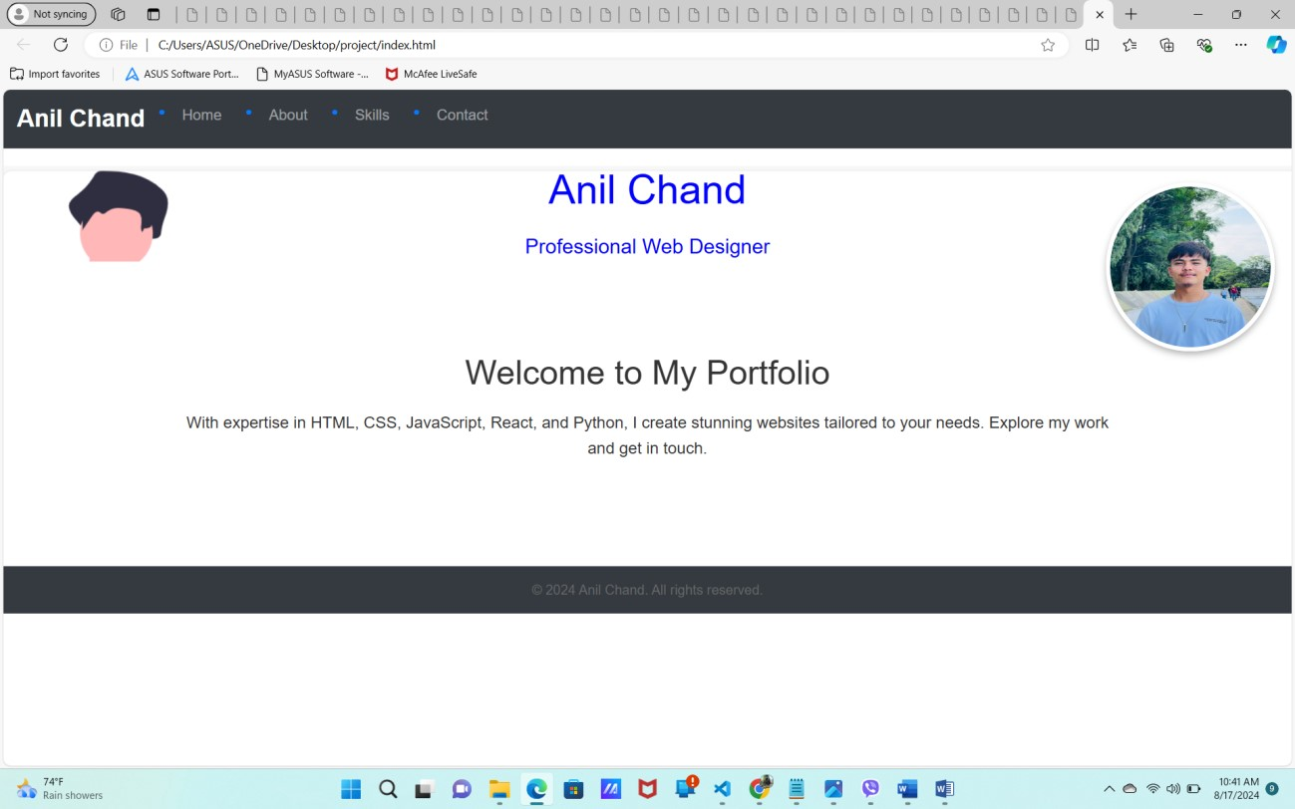

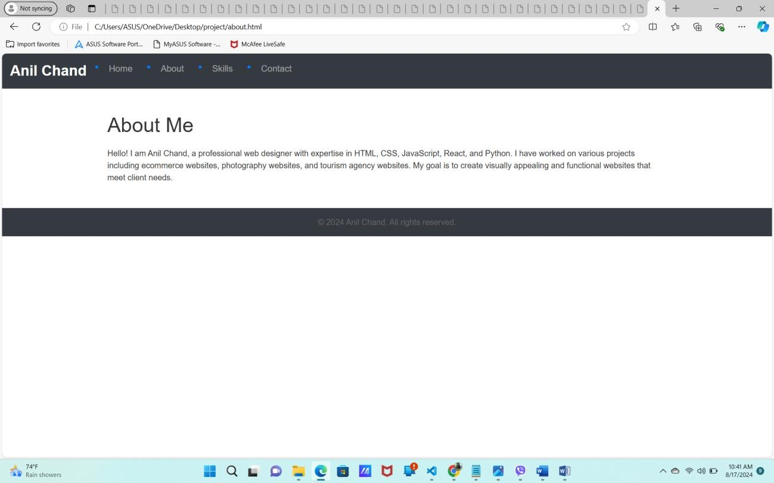

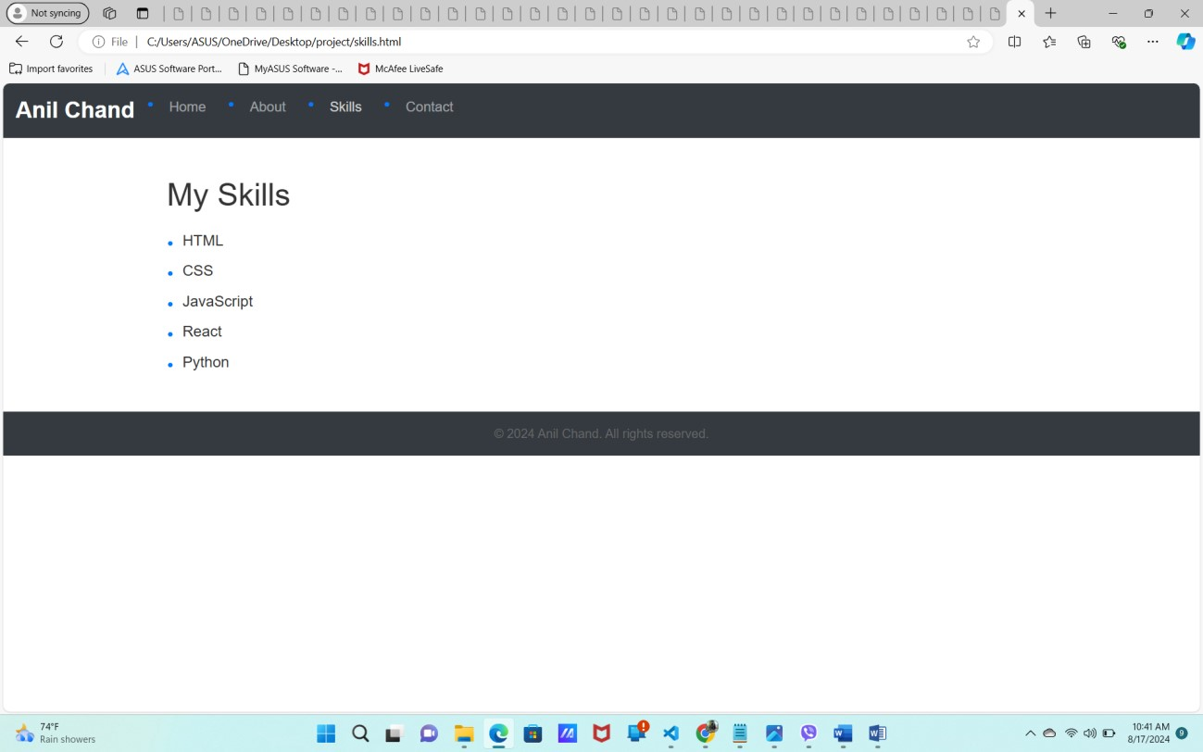

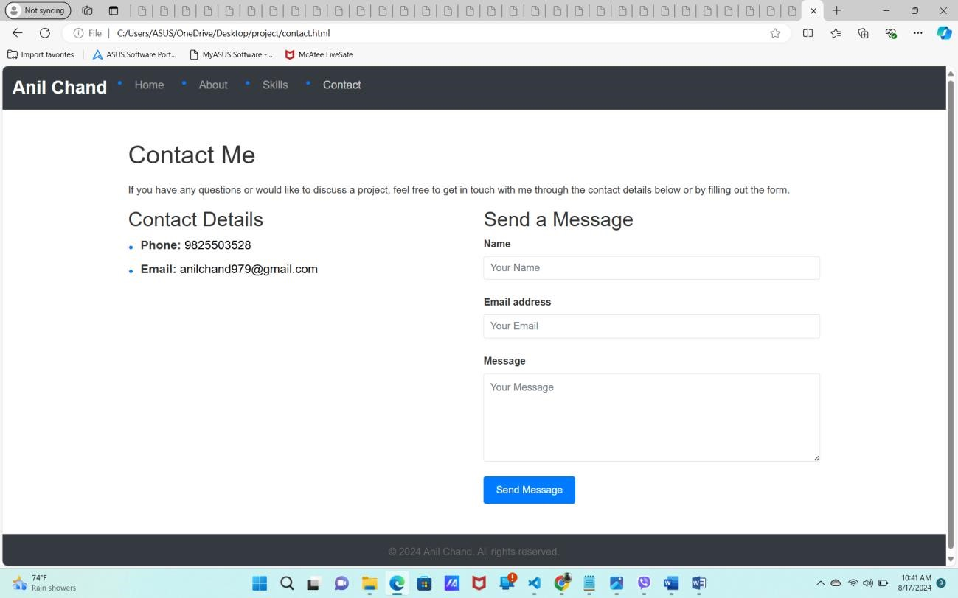

1. Conclusion

The project provided a practical experience in building a professional portfolio using HTML, CSS, and Bootstrap. It reinforced the importance of responsive design and the benefits of using Bootstrap for rapid development. The resulting website meets the project objectives and serves as a strong representation of the web designer's capabilities.

1. References
   * Bootstrap Documentation: https://getbootstrap.com/docs/5.0/gettingstarted/introduction/
   * MDN Web Docs: HTML, CSS, and JavaScript resources.
   * Stack Overflow: For troubleshooting errors and finding solution

# The end